**4B OS LAB-03 ASSIGNMENT**

# **CS182019 | MUHAMMAD DANISH |3B**

# **Q1)**

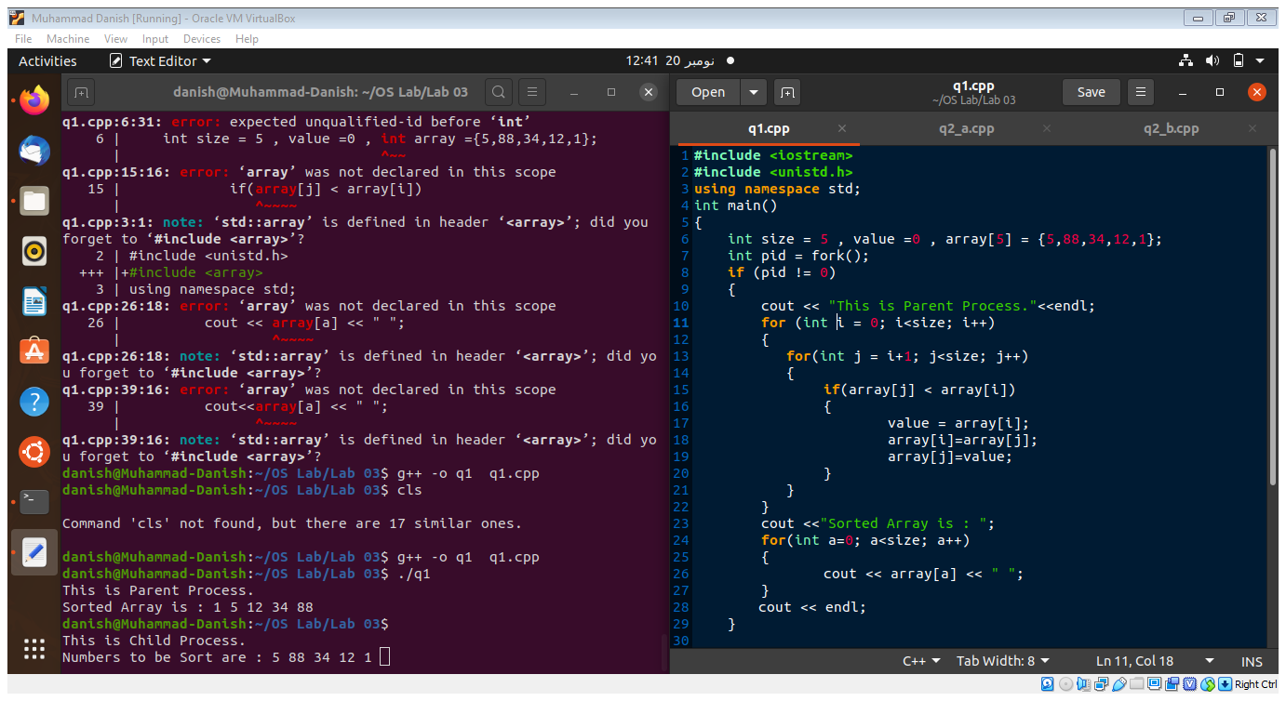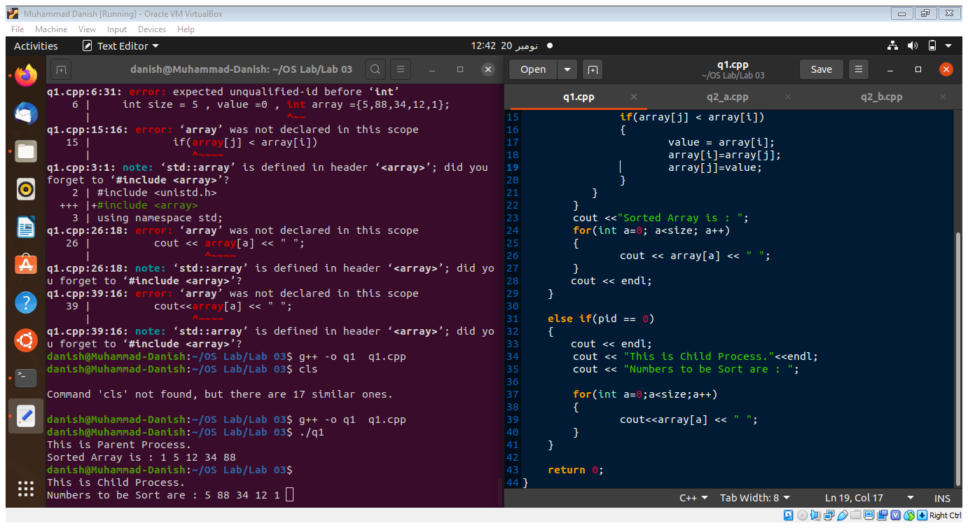



# **Q2_A)**

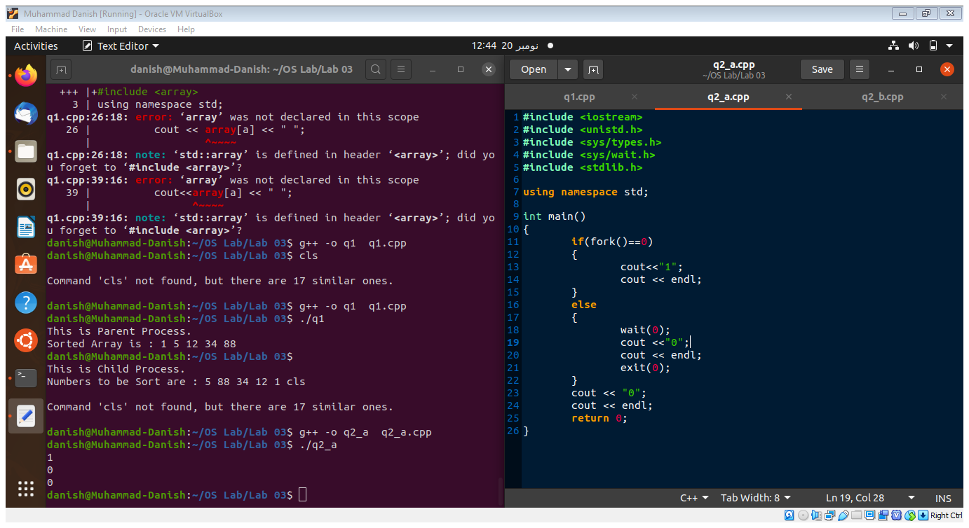

**First of all when fork() is called in the if statement it will generate a child of the parent process. When wait(0) is called the parent process will halt until the child process is executed,**

**Hence the output is 1, 0, 0 .**

# **Q2_B)**

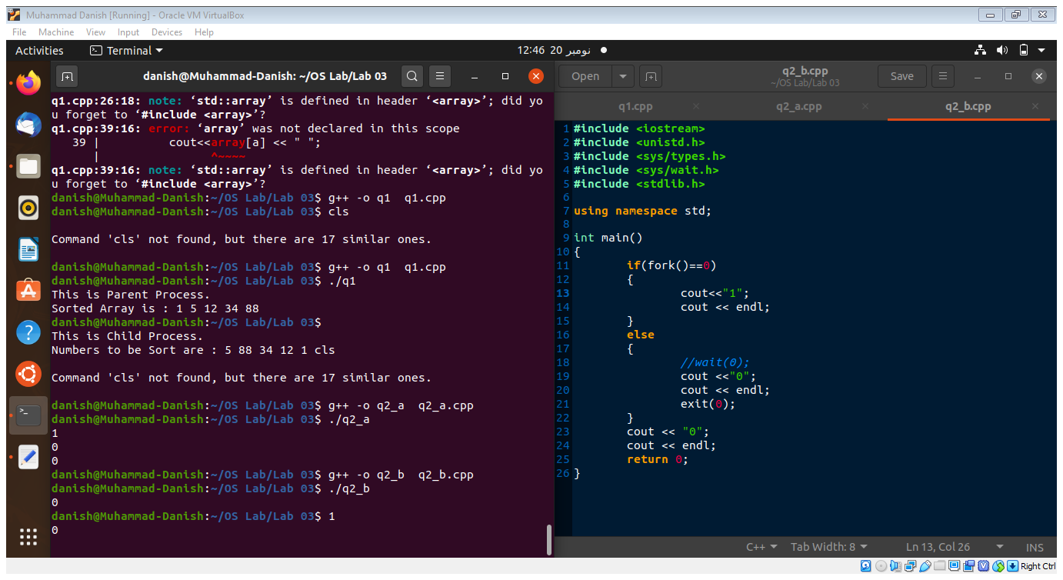

**There is no call of wait() this means that the parent process will not halt and it will execute first. Than the child process printing the 1. And at the last value 0 in the main() parent process is printed.**

**Hence the output is 0 ,1 ,0 .**

# **CS182019 | MUHAMMAD DANISH |3B**